## AX.X – Description of Analytic Methods and Rasch Model Data Validation for the Food Insecurity Experience Scale (FIES)

In this section we provide details on the statistical outputs for the Rasch model for the Baseline and Midline Surveys.

**Imputation and Missing Data**

There are two types of missing values that may be encountered when analyzing the FIES: (1) households for which all FIES items are missing, and (2) households that skipped or refused select individual FIES items and responded to others. In terms of the former, there were 7 households for the Baseline without any reason provided and there were 14 households for the Midline. Regarding information on consent among these households, no reason was provided for any of the 7 households with no data for the Baseline. For the Midline, 13 households had Respondent Not Available and 1 with Other as reasons for not obtaining consent.

In terms of individual items, the table below outlines missing data on individual items for the FIES. All items with missing data were due to refusal of specific items on the FIES in the Baseline survey – there were no missing items for the Midline.

In the case of the Baseline, imputation was successfully completed for all missing items. Based on the guidance provided in the Guide to Statistics, values were imputed only for missing items when the pattern of the responses was clear; such as when the most immediate less and more severe items surrounding the item with missing data had the same response (either all ‘yes’ or all ‘no’). In the case of the final item, all responses were coded to ‘No’ given that the closest item (7. Hungry) also had ‘No’ for all of these households.

**Table 1: Number of Refusals on the FIES Items for the Uganda P-2 ZOI & RFZ Baseline & Midline Surveys**

|  |  |  |
| --- | --- | --- |
| Item | Baseline | Midline |
| 1. Worried | 0 | 0 |
| 1. Few Foods | 0 | 0 |
| 1. Healthy | 2 | 0 |
| 1. Ate Less | 0 | 0 |
| 1. Skipped | 1 | 0 |
| 1. Runout | 2 | 0 |
| 1. Hungry | 1 | 0 |
| 1. Run Out | 3 | 0 |

**Diagnostics**

There are four main diagnostics that must be examined thoroughly to assess model fit: infit, outfit, Rasch reliability, and principal component analysis (PCA) on the residual matrix. Additionally, the item severity scales for the eight FIES questions are compared across survey rounds to ensure that they are consistent. In this section, we provide details on the results for each diagnostic.

**Item Infit**

Item infit determines the extent to which there are unexpected patterns of observations by households on items close to their placement on the latent scale (or their relative level of food insecurity). Specifically, are there any questions which have responses that do not fall the expected hierarchy of the level of severity assigned to them? Item infit values less than 0.7 and above 1.3 are considered to be problematic and it is recommended to remove these items from inclusion in the Rasch model. In both the Baseline and Midline surveys, no items were observed to have values outside of the acceptable range and no items had to be removed.

**Table 2: Item Infit Values for the Eight FIES Items**

|  |  |  |
| --- | --- | --- |
| Item | Baseline | Midline |
| 1. Worried | 1.14 | 1.07 |
| 1. Few Foods | 1.06 | 1.23 |
| 1. Healthy | 1.07 | 1.03 |
| 1. Ate Less | 0.90 | 0.98 |
| 1. Skipped | 0.87 | 0.85 |
| 1. Runout | 0.85 | 0.75 |
| 1. Hungry | 0.79 | 0.84 |
| 1. Run Out | 1.02 | 1.05 |

**Reliability (Flat) Statistic –**

The Rasch reliability (flat) statistic is an estimate of how much the variability is explained by the Rasch model. Similar to an R-squared in the context of a regression, the flat statistic is between 0 and 1 and the closer the value is to 1, the better that the model fits the data. Usually, low item reliability is because the person sample size is too small to establish a reproducible item difficulty hierarchy. If reliability is lower than the suggested threshold of 0.7 and the standard deviation is lower than 1.5, the next step is to examine respondent Outfit values to remove households that have outlier response patterns (i.e. respondents who respond "YES" to items out of line with the severity of the items).

In both the Baseline and Midline surveys, there is no such problem: the reliability statistic and the standard deviation are both in the acceptable range.

|  |  |  |
| --- | --- | --- |
|  | Baseline | Midline |
| Reliability | 0.76 | 0.76 |
| Standard Deviation | 1.72 | 1.78 |

**Analysis of Variance Not Explained by Model**

A principal component analysis is run on the residual matrix of the Rasch model to inform what the variance not explained by the model looks like. Ideally, the screeplot of the items should show a gradual drop-off in the residual variance and should not be in an ‘L’ or hockey stick shape. Such a shape would suggest that the model is capturing factors not explained by the FIES items and non-measured factors are influencing the results.

In the screeplots provided below, both the Baseline and Midline surveys can be observed to have a gradual drop-off of residual variance and do not exhibit any concerning behavior.

**Plot 1: Proportion of Variance Explained by Residuals of the Rasch Model of the FIES for the Uganda Baseline and Midline Surveys**

**Comparing Item Severity Scores Across Rounds**

As a final step, we comparatively assess the positioning of item severity for the eight FIES items in the Baseline and Midline surveys. This is a necessary step before calibrating the survey item severity scores for each to produce moderate and severe food insecurity rates.

Ideally, the hierarchy of item severity for each item will be similar across survey rounds and not exhibit significant differences in the order of items. If item severity scores significantly changed from one round to the next due to significant improvement or worsening in food security prevalence, the hierarchy of items within each round should remain similar.

For this, the item characteristic curve (ICC) plots of the Baseline and Midline surveys are used to determine the expected probability of responding ‘yes’ to a given FIES item based on the level of severity of the respondent. When examining the ICC plot for the Baseline, a respondent with a level of 2 severity parameter (x-axis) would have a probability of 1.0 of responding ‘yes’ to the FEWFOODS, WORRIED, and HEALTHY items.

**Plot 2: Item Characteristic Curves of the FIES for the Uganda P-2 ZOI & RFZ Baseline and Midline Surveys**

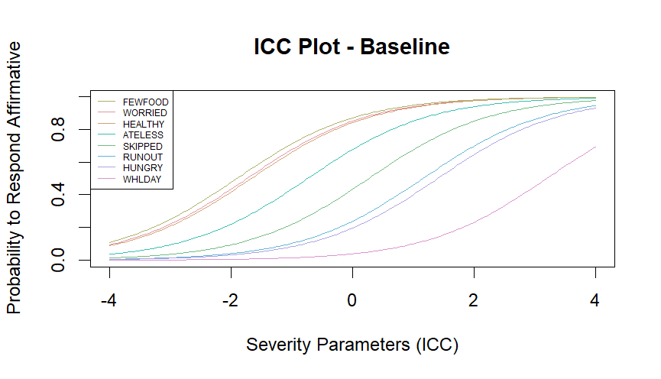

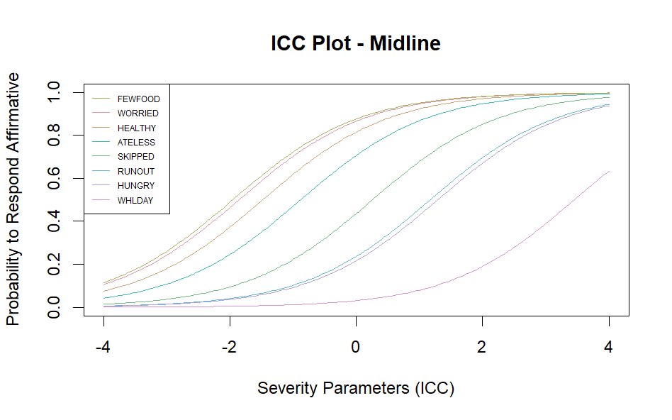

In this plot, the hierarchy of the items remains consistent across both surveys. Although the items as a whole are more severe in the Midline survey, the structure appears quite similar. For example, in both surveys the FEWFOODS item is the least severe, the WHLDAY item is most severe, and the hierarchy of every item in between them is the same for both survey rounds. Additionally, we observe similar characteristics in each plot, where the first three items are bunched together, ATELESS is a less severe item than SKIPPED (in theory the questions are asked in order of increasing severity and ATELESS is asked after SKIPPED), and the WHLDAY item is removed from the rest of the items, with only the most severe respondents having a probability greater than 0.5 of responding affirmatively.

As a next step, the item severity scores divided by its standard deviation is calculated and then plotted with the Baseline on the x-axis and the Midline on the y-axis. It should be expected that values will not significantly deviate from the diagonal line; items with scores on the line can be considered to have the same relative level of severity in each round. For Uganda, it can be seen that none of the items significantly diverge from the line and there is less divergence among more ‘severe’ items.

**Plot 3: Item Severity Scores for the Baseline and Midline Surveys**

